GENERIC METHOD –01.08.2024

1) write a java program to create generic method that take list of numbers and return sum of all even and odd numbers

import java.util.List;

public class SumEvenOdd {

public static <T extends Number> void sumEvenOdd(List<T> numbers) {

int sumEven = 0;

int sumOdd = 0;

for (T number : numbers) {

if (number.intValue() % 2 == 0) {

sumEven += number.intValue();

} else {

sumOdd += number.intValue();

}

}

System.out.println("Sum of even numbers: " + sumEven);

System.out.println("Sum of odd numbers: " + sumOdd);

}

public static void main(String[] args) {

List<Integer> intList = List.of(1, 2, 3, 4, 5, 6, 7, 8, 9, 10);

sumEvenOdd(intList);

List<Double> doubleList = List.of(1.0, 2.0, 3.0, 4.0, 5.0);

sumEvenOdd(doubleList);

}

}

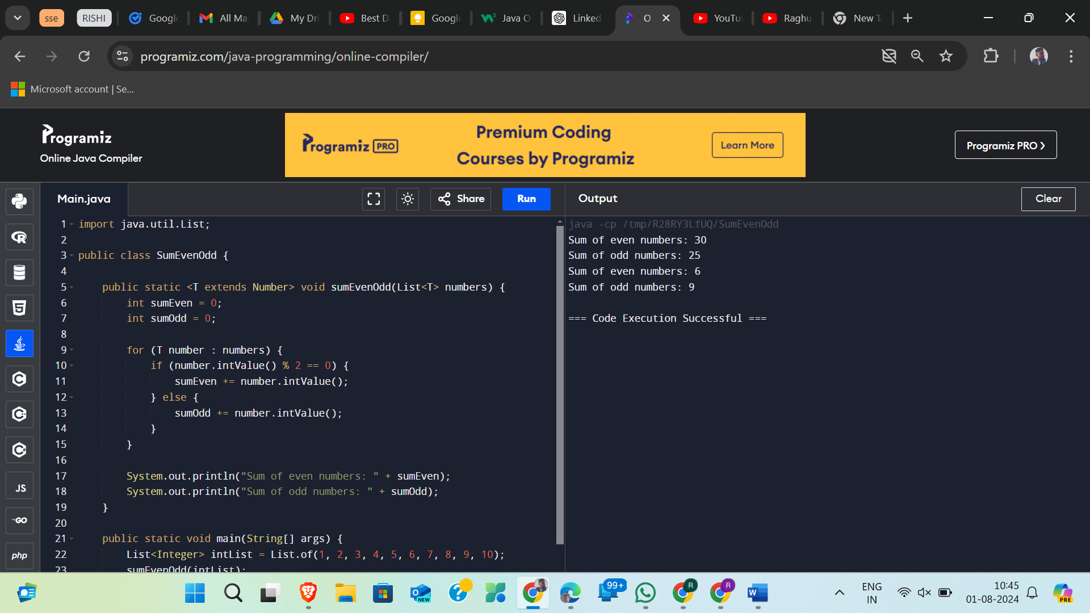

2) write a java program to create generic method that take list of any types and a target element and retutn the index of first occurrence of target element in list return -1 if target element cannot be found

import java.util.List;

public class FindElement {

public static <T> int findFirstOccurrence(List<T> list, T target) {

for (int i = 0; i < list.size(); i++) {

if (list.get(i).equals(target)) {

return i;

}

}

return -1;

}

public static void main(String[] args) {

List<String> stringList = List.of("apple", "banana", "cherry", "date");

System.out.println("Index of 'banana': " + findFirstOccurrence(stringList, "banana"));

System.out.println("Index of 'fig': " + findFirstOccurrence(stringList, "fig"));

List<Integer> intList = List.of(1, 2, 3, 4, 5);

System.out.println("Index of 3: " + findFirstOccurrence(intList, 3));

System.out.println("Index of 6: " + findFirstOccurrence(intList, 6));

}

}

